Design Thinking Process

Contents

Introduction 1

Empathize 2

Stats for Simon 2

Assumptions and Context 3

Business trends 3

Define 3

Point of View statements 3

How Might We questions 3

Ideate 4

Braindumping session 4

Daan 4

Sharony 4

Brainstorming session 4

Concept 5

Specific skills roadmap 6

Introduction 6

Features 6

Priority 6

Remote-dev-app 7

Introduction 7

Features 7

Priority 7

Sources 7

# Introduction

This document was made in support of the process concerning the first project within the fourth semester of the ICT study at Fontys Hogescholen Eindhoven. This project and all its deliverables are a joint effort of Sharony Braam and Daan Brocatus. The domain that was provided by FHICT is ‘Business’. The persona connected to this domain is Business Owner Simon, who is displayed below.

# Empathize

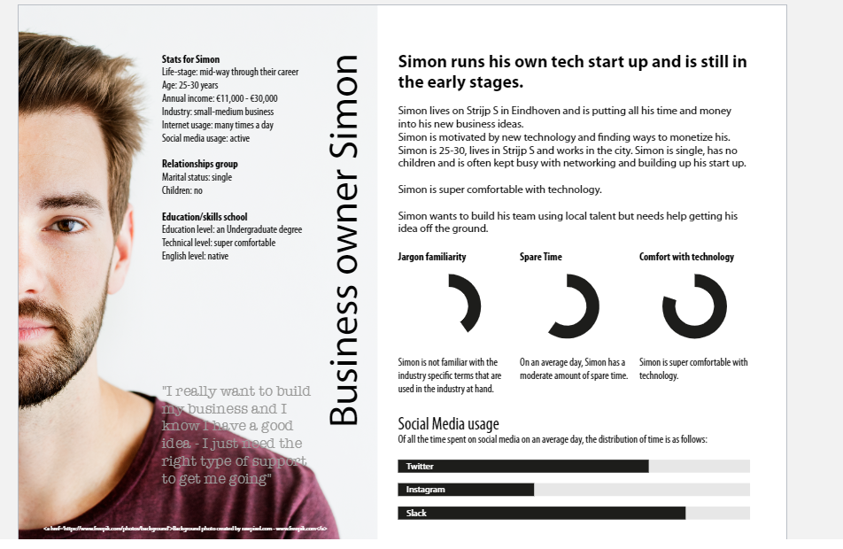

## Stats for Simon

**Life-stage:** mid-way through their career

**Age:** 25-30 years

**Annual income:** 11,000 – 30,000

**Industry:** small-medium business in tech

**Internet usage:** Many times a day, active on social media

**Marital status:** single

**Children:** no

**Education level:** and undergraduate degree

**Technical level:** super comfortable

**English level:** native

**Goal:** “I really want to build my business and I know I have a good idea – I just need the right type of support to get me going”

## Assumptions and Context

* Simon runs his own tech start up and is putting all his time and money into his new business ideas.
* He is very motivated by new technology and finds ways to monetize this.
* He is often kept busy with networking to find local talent and building up his start up.
* Simon strives to grow his tech-startup, preferably with local talent.
* Simon most likely needs help with the technical aspects of developing his ideas.
* He most likely owns a startup that wants to focus on software since it’s hard for a start up to focus on multiple hardware ideas with the amount of money that he has.
* In his free time he most likely uses a lot of social media.
* He most likely drives around in a city car.
* He mostly likely lives in an apartment because he uses all his money for his start up and lives in Strijp-S. According to the source listed below, the rent in Strijp-S is quite high.

## A day in Simon's life

Simon lives in a small apartment in Strijp-S. He wakes up at 08:00 and takes a shower. He eats his breakfast at 08:30 and starts working at 09:00. Because of the current situation regarding the SARS-CoV-2 virus, he can’t go to his office in Strijp-S. He starts with researching technological job offers since he still needs to find local talent. He spends all morning doing this and at 12:00 he makes some lunch. After lunch he starts making business processes for all his ideas. It’s around 16:00 when he finishes and grabs his car to do some grocery shopping. After the grocery shopping he starts preparing dinner. When it’s done he watches Netflix and eats his dinner. With the remaining time he searches for local talent and scrolls through Twitter. At 22:00 he watches some more Netflix and at 00:00 he goes to bed.

## Business trends

1. Drug development revolution with advanced Covid-19 testing and vaccine development
2. Continued expansion of remote working and videoconferencing
3. Contactless delivery and shipping remain as the new normal
4. Telehealth and telemedicine flourish
5. Online education and e-learning as part of the educational system
6. Increased development of 5G infrastructure, new applications and utilities
7. A.I., robotics, internet of things, and industrial automation grow rapidly
8. Virtual Reality (VR) and augmented reality (AR) technologies usage rises
9. Continued growth in micro mobility
10. Ongoing autonomous driving innovation

# Define

We identified PoV-statements using the information we gathered in the Empathize stage of the process. We incorporated trends within the Business domain and tried to apply them to Simon’s case. Then we translated the PoV-statements to How Might We questions and discussed them.

## Point of View statements

* Simon needs technological support in order to realize his new business ideas
* Simon needs to monetize new technology because he wants his startup to grow
* Simon needs to network because he wants to recruit local talent for his business
* Simon needs to use a lot of social media because he wants to expand his social circle

## How Might We questions

* How might we help Simon find local talent in the software sector in order to support his startup?
* How might we enable Simon to monetize new technology trends?
* How might we improve the rate at which Simon is able to network, in order to speed up his recruitment process?
* How might we help Simon manage his social media accounts?

# Ideate

We individually braindumped for about fifteen minutes. We then met up and talked over our ideas. In the brainstorming session we looked at every idea we had and decided on which ones were viable. We also constructed some more information on every viable idea.

## Braindumping session

### Daan

* Tinder-like recruiting application for software engineers
* Technology trend web-scraping app
* App for posting the same text/post on multiple socials
* Scan entity for tech trends regarding the subject app
* E-learning roadmap app for specific skills (project scope)
* App for translating a new technology to a business model
* App for comparing existing software job offerings
* App for getting notifications about new tech trends or developments
* App to track ideas and get tips about them through web scraping keywords
* Remote-dev-app to connect with remote developers.

### Sharony

* Tinder-esque recruiting application for technological support
* Code with me through phone
* Talent-finder and hire for a project only like UpWork
* Technology trend web-scraping app with notifications
* Technology app that keeps track of a certain technology and sends notifications
* New networking application
* Tinder-esque application for finding social media hosts
* App that keeps track of all his inboxes from his emails and put them in one place so that he can answer them
* App that keeps track of all his social media inboxes
* App that helps Simon get more technological knowledge
* App that tests the local talent to find out if they are good enough for Simon
* Monitoring system app so that he can keep track of the new employees because of corona
* Health app
* App for finding recruiters that help Simon find talent
* App that keeps track of corona developments
* App that helps Simon with healthy food because he spends so much time on his business
* Planner app for Simon
* Calendar app for meetings

## Brainstorming session

* Tinder-esque recruiting platform for developers/technological support/software engineers
  + GPS for connecting with local people
  + **Test assumed knowledge of developers**
* Technology trend tracking app
  + Web-scraping
  + Push notifications
* App for posting the same text/post on multiple socials
  + Connection with social media platforms
  + Push notifications
  + Timer on when a post is posted
* E-learning roadmap app for specific skills
  + Specific skills/platform
  + Tutorials/resources
  + Personal roadmap (per project based)
  + Web scraping
  + Push notifications for reminders or updates
* App for comparing existing software job offerings
  + Compare compensation/required skillset
  + Web scraping/API
* App that tracks certain keywords and sends notifications about news on them
  + Push notifications
  + Web scraping
* Remote-dev-app
  + Hire freelancers
  + ’test out’ freelancers before hiring them
  + Project-based assignments
  + GPS for location tracking
* Tinder-esque application for finding social media hosts
  + Socials as portfolio
  + Integration with other social
* App that tracks socials inboxes and email inbox
  + Reply integration with socials/email
  + Push notifications
* App that helps Simon with healthy food because he spends so much time on his business
  + Diet suggestions -> planning with notifications
  + GPS for (grocery) stores nearby

## Concept

In order to pick an idea we wrote down a few factors we want to consider when making this decision. We then continued to rate each idea within the factors we came up with in order to pick a winner. The factors we considered are:

1. *Enthusiasm*: how enthusiastic are we both about this concept?
2. *Achievable*: is it possible to create a working MVP within the timespan given?
3. *Innovation*: is it a fresh or creative idea?
4. *LO*: does the concept match the learning outcomes provided?

The table provided below describes the ratings we have given to each idea and the idea with the highest rating.

|  |  |  |  |  |  |
| --- | --- | --- | --- | --- | --- |
|  | Enthusiasm | Achievable | Innovation | LO | Avg |
| Recruiting platform | 6,5 | 8,0 | 4,0 | Yes | 6,16 |
| Trend tracking | 7,0 | 5,0 | 6,5 | Yes | 6,16 |
| Posts manager | 5,5 | 4,5 | 6,0 | Yes | 5,33 |
| **Specific skills roadmap** | **8,0** | **6,5** | **8,0** | **Yes** | **7,50** |
| Job offer comparer | 5,0 | 6,0 | 4,0 | Yes | 5,00 |
| Keyword tracker | 7,0 | 5,5 | 6,5 | Yes | 6,33 |
| Remote-dev-app | 7,0 | 8,0 | 4,5 | Yes | 6,50 |
| Social media hosts Tinder | 5,5 | 5,0 | 5,0 | Yes | 5,16 |
| Socials manager | 7,5 | 4,0 | 6,5 | Yes | 6,00 |
| Health/diet app | 7,0 | 6,5 | 5,5 | Yes | 6,33 |

## Specific skills roadmap

### Introduction

Our idea is to create an application that enables the user to enter project specific skills (Such as smaller subjects within programming environments: e.g. Android API connection, iOS User Experience Design for buttons, etc.). The application then provides the user with a unique roadmap in order to acquire the knowledge and skills necessary to implement these subject within a project or application.

### Features

* A user can enter keywords he wants tutorials on
* The application provides the user with multiple sources based on the keywords entered
* The application provides the user with multiple types of sources (literature, examples, videos, free, paid, etc.) based on the keywords entered
* A user can create an account to save a roadmap
* A user can track their progress on a roadmap
* A user can have multiple roadmaps (at once)
* A user can set notifications for a roadmap (achievements! reminders and/or updates about them)
* A user can perform CRUD operations on their roadmap
* A user can perform CRUD operations on their account
* A user can export their roadmap to their Google Calendar

### Priority

|  |  |
| --- | --- |
| **Priority** | **Feature** |
| High (MVP) | * A user can enter keywords he wants tutorials on * The application provides the user with multiple sources based on the keywords entered |
| Medium | * A user can set notifications for a roadmap (reminders and/or updates about them) * The application provides the user with multiple types of sources (literature, examples, videos, free, paid, etc.) based on the keywords entered * A user can track their progress on a roadmap * A user can perform CRUD operations on their roadmap * A user can export their roadmap to their Google Calendar |
| Low | * A user can perform CRUD operations on their account * A user can create an account to save a roadmap * A user can have multiple roadmaps (at once) |

## Remote-dev-app

### Introduction

Within this concept there are two ‘types’ of users: users that register a project and look for developers, and users that are looking for a project to work on. The application shows available projects and their pay rates. Users can click on them for more information and send their CV/skillset to the project owner if they are interested.

### Features

* A user can register a project
* Users are provided with an overview of all available projects that match their skillsets
* Users can contact project owners and send their skillsets
* Users can provide personal skillsets on their account
* Users are provided payment based on either a project or hourly rate
* A user can perform CRUD operations on their project
* A user can perform CRUD operations on their account

### Priority

|  |  |
| --- | --- |
| **Priority** | **Feature** |
| High (MVP) | * A user can register a project * Users are provided with an overview of all available projects that match their skillsets * Users can contact project owners and send their skillsets |
| Medium | * Users can provide personal skillsets on their account * Users are provided payment based on either a project or hourly rate |
| Low | * A user can perform CRUD operations on their project * A user can perform CRUD operations on their account |

# Sources

* Funda. (n.d.). Huurwoningen Strijp-S. Retrieved 26 February 2021, from <https://www.funda.nl/huur/eindhoven/strijp-s/sorteer-huurprijs-op/>
* iteraction-design.org. (n.d.). Problem Statements. Retrieved 26 February 2021, from <https://www.interaction-design.org/literature/topics/problem-statements>
* Uzzaman, A. (2021, January 5). Top Business and Technology Trends in 2021. Retrieved 26 February 2021, from <https://www.inc.com/anis-uzzaman/top-business-technology-trends-in-2021.html>